Project Design Phase-II
Data Flow Diagram & User Stories

Date | 30 September 2026
Team ID | SWTID-2026-4475
Project Name | Implement Client Script & UI Policy (Incident)
Maximum Marks | 4 Marks

Data Flow Diagrams:
A Data Flow Diagram (DFD) is a traditional visual representation of the information flows within a system. A neat and clear DFD can depict the right amount of the system requirement graphically. It shows how data enters and leaves the system, what changes the information, and where data is stored.
DFD Level 0 - Implement Client Script & UI Policy (Incident)
Example:
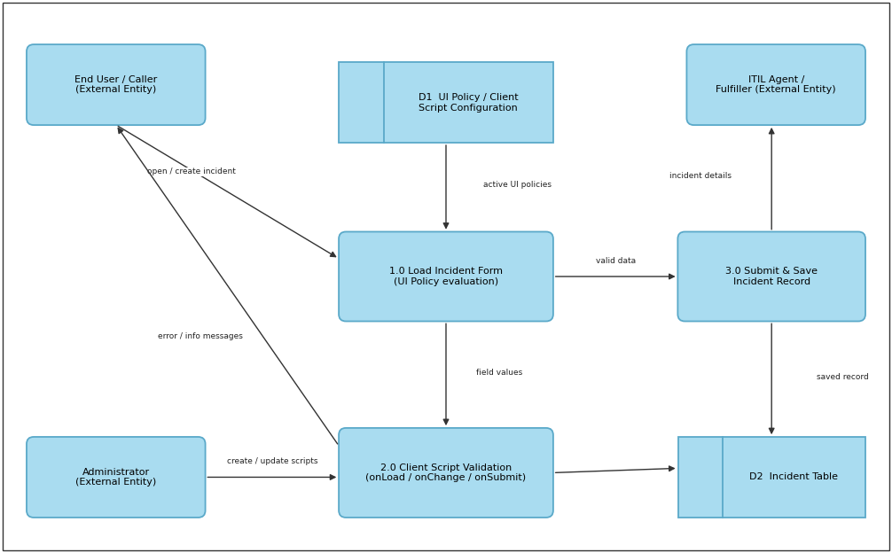
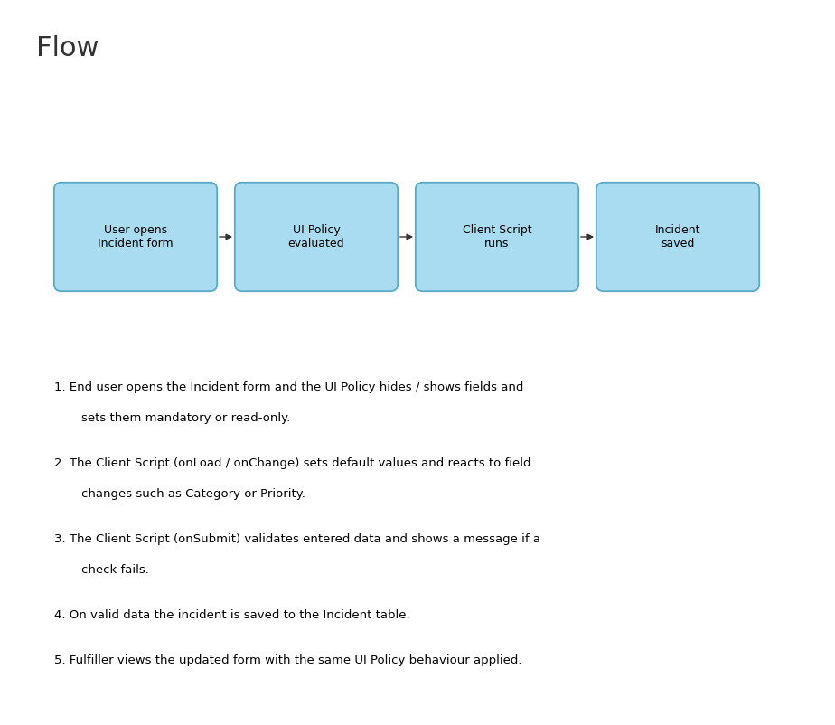

User Stories
Use the below template to list all the user stories for the product.
User Type | Functional Requirement (Epic) | User Story Number | User Story / Task | Acceptance criteria | Priority | Release
End User (Caller) | Incident Form Behaviour | USN-1 | As a caller, I can open the Incident form and see only the fields relevant to me, so that I can raise an incident easily. | I can view the form with fields shown / hidden as per the UI Policy | High | Sprint-1
 |  | USN-2 | As a caller, I am required to fill the mandatory fields (Short description, Category) before submitting the incident. | I cannot submit the incident until mandatory fields are filled | High | Sprint-1
 |  | USN-3 | As a caller, I see the Contact type and Impact fields set to default values when the form loads (Client Script - onLoad). | I can see default values populated on load | Low | Sprint-2
 |  | USN-4 | As a caller, when I change the Category, the Subcategory list is updated (Client Script - onChange). | I can see only relevant Subcategory values | Medium | Sprint-1
 | Form Validation | USN-5 | As a caller, I receive a clear message if I enter invalid data while submitting the incident (Client Script - onSubmit). | I can see an error message and correct the data | High | Sprint-1
 | Confirmation | USN-6 | As a caller, I can save the incident successfully and view the incident number. | I can see the saved incident with its number | High | Sprint-1
ITIL Agent (Fulfiller) | Incident Handling | USN-7 | As an agent, I can see the Resolution fields as mandatory only when the State is set to Resolved (UI Policy). | I cannot resolve an incident without resolution notes | High | Sprint-2
 |  | USN-8 | As an agent, I can see certain fields as read-only after the incident is closed (UI Policy). | I cannot edit fields of a closed incident | Medium | Sprint-2
Administrator | UI Policy Configuration | USN-9 | As an administrator, I can create and activate UI Policies on the Incident table with conditions and actions. | I can see the UI Policy applied on the Incident form | High | Sprint-1
 | Client Script Configuration | USN-10 | As an administrator, I can create Client Scripts (onLoad, onChange, onSubmit) on the Incident table. | I can see the script executing on the Incident form | High | Sprint-1
 | Testing | USN-11 | As an administrator, I can test the UI Policies and Client Scripts by creating a sample incident. | I can confirm all form behaviours work as expected | Medium | Sprint-2
Customer Care Executive | Support | USN-12 | As a support executive, I can raise an incident on behalf of a caller with the same form behaviour applied. | I can submit the incident on behalf of the caller | Medium | Sprint-2

